Claudio Castillo

CTS 2451

Prof. Norge Pena

01/23/2019

**Discussion 3- Tutorial IV**

The goal of this tutorial is to give an idea on how to create a tabular report without using the wizard. In previous tutorials and reports we already went through the process of attaching the Galactic database to our environment, then every time we need it we can just use the connection string when adding a shared data source to our report solution.

1. Create a new project and give the location to the solution folder. This project I called it Discussion 3.
2. Add the database where we are going to query all the information from (data source). On this case we are using the Galactic Database. Notice that in my case I am using the OLE DB in order to get the visual query designer that will be useful later on in the discussion.

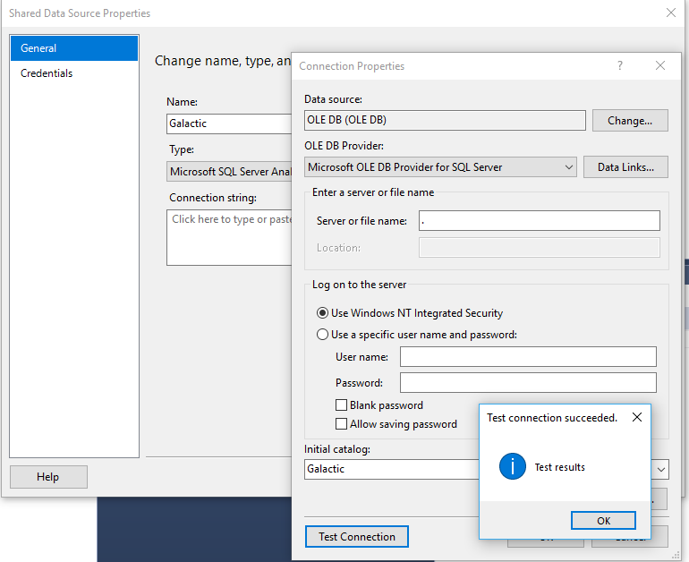

1. 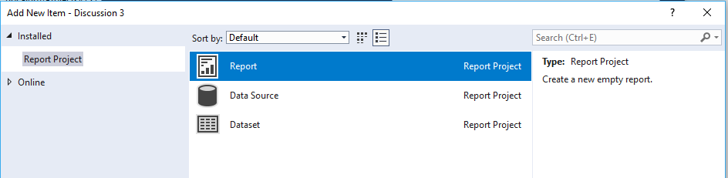Avoiding the prompt for the wizard is really easy. Right click on the Reports folder of the Solution Explorer window and select Add and then New Item from the dropdown menu. A new window will pop up and then select Report from the options shown there. Don’t forget to change the name of the report before clicking OK
2. After this point we are going to connect the data source to our report and create our dataset. On the report data window, right click the data sources folder and select add new data source. Make sure to give it a name and to select Use shared data source reference option. Remember that we already created a connection string to the database we have attached in SQL.

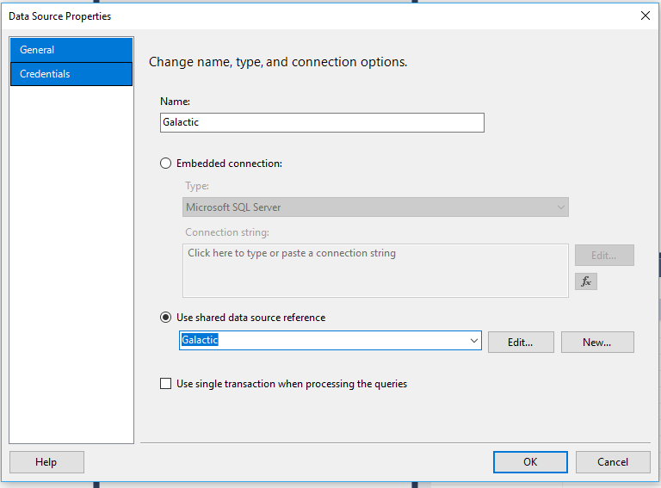

1. 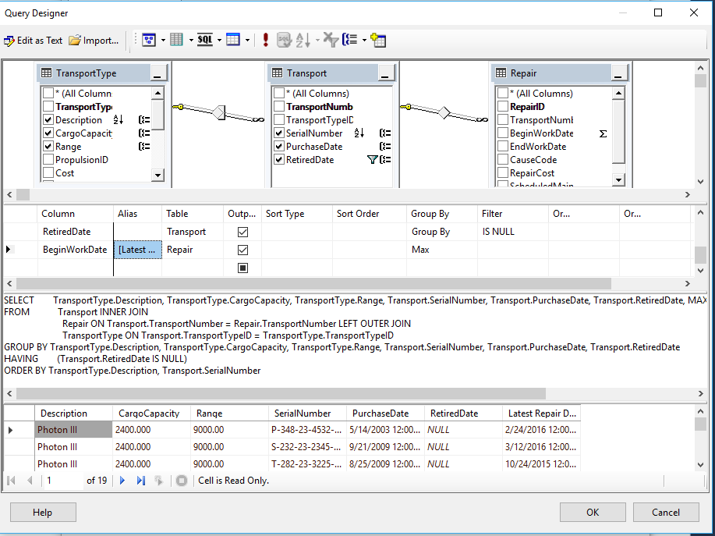Now it is time to query. Or to create the Dataset we are going to be using in our report. Using the query designer, we are going to select Transport, TransportType and Repair tables. From which we are going to select the following columns: description, cargo capacity, range, serial number, purchase date, retired date, begin work date. Add a Group By clause and change to MAX aggregate function the BeginWorkingDate column.
2. After we are going to add a table to our report and add some of the field. Later we are going to add a group to display in a better way our results. This include some changes in the layout and in the 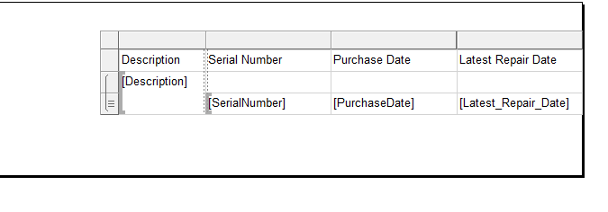font of the data.

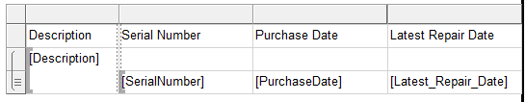

After this point we are asked to merge the cells above and to type some code in the expression builder that will give us the cargo capacity and the range of each group.

This is the general layout:

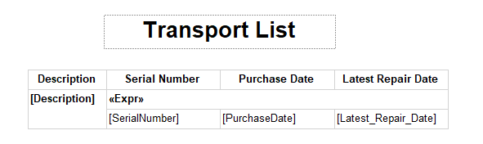

And this is the report preview:

